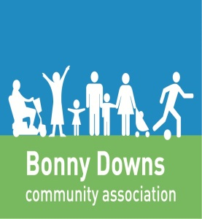
BDCA After School Club
Photography Policy
Photographs are a valuable tool for recording and assessing children’s activities and achievements in BDCA After School Club.
Photographs will only be taken with digital cameras or approved BDCA work mobile camera phones. Staff personal mobile phones must be kept in their lockers at all times, and not handled whilst looking after the children. Any emergency calls must be made via the After School Clubs main telephone line. Any member of staff found using a mobile phone without permission to do so may be subject to disciplinary action.
Photographs will only be taken during normal After School Club activities. Cameras will never be used in the toilets/changing areas. A child will never be photographed when their clothes are being changed.
Parents/Carers will be asked to read and sign the Photo Permission Form when their child starts attending the After School Club. If a Parent/Carer does not give permission for their child to be photographed, all staff will be informed so that all reasonable steps can be taken to ensure that the child is not included in any photographs.
Only BDCA After School Club staff who has an enhanced DBS disclosure are permitted to take photographs within the setting. Parents and Volunteers are not permitted to take photographs within the setting without prior permission from management. However, at public events (e.g., Christmas Parties, Sports Days, and Charity Events etc.), family members and press photographs may take photographs of the public activity. We do respectfully ask that such photos or videos are only shared amongst friends and families and NEVER posted onto social media site.
Parents/Carers will be asked not to take photos of any Children except their own within the setting unless the staff on duty has witnessed consent from that Childs Parent/Carer.
Whilst pictures may be used as part of publicity of the After School Club, no pictures of children will be displayed on the BDCA website, in press or on television without Parents/Carers written permission on the registration form. Where pictures are made available to the press or television, they will not be released with the names of the child unless the Parent/Carer gives permission for this to be done.
Photographs may be printed and displayed within the After School Club. Photographs will only be stored on the After School Club computers and can be inspected by management at any time.

This policy was adopted by: BDCA After School Club | Date:05/09/2017  Amended 4/9/18
To be reviewed:05/09/2019 | Signed:

Written in accordance with the EYFS welfare requirement: Safeguarding and promoting children’s welfare.

